Week in Review: November 30 - December 5
Alex Shvartsman

Player and Rookie of the Year Races
Alert the media - nothing really amazing happened in the world of competitive Magic this week. Seems like a good time to stand back and take a look at the current Player of the Year race - or lack thereof. As you know, Kai Budde is dominating the standings at a whopping 67 points, leaving little doubt as to who is going to be crowned Player of the Year next summer. Even if Walamies wins Pro Tour-San Diego, Budde would still be ahead by a significant margin.
So why bother discussing the standings at all? Several of the players at the top of the standings are going to play in the Magic Invitational in Argentina next year. These players are also the ones you will likely be seeing in the Masters Series events over the next year, as well as a number of Feature Matches - so it's worth paying some attention. Oh, and there might actually end up being a race for Rookie of the Year - you just never know!
So let us examine the current top 10 in the Player of the Year race:
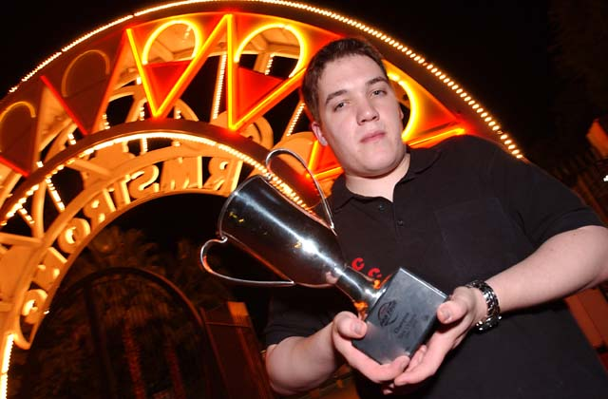
1) Kai Budde, 67 points. Budde has won both Pro Tours this season and Grand Prix-London. He also finished second in GP-Biarritz, maintaining a near-perfect record. Budde does not need to do much more in order to win the title, but you can be sure he'll continue to post top tournament finishes anyway.
2) Tomi Walamies, 32 points. Walamies, Finland, has been on the Tour for a long time, with varying results, but this is the first season where he enjoys a spot at the very top of the standings. Walamies finished second at PT-New Orleans with a Turbo-Herd deck of his own making. His team, The Punisher, which combines some of the best players from Finland and Sweden, has been a rising force on the Pro Tour over the course of the last six months. With their support, Walamies may be able to hang on to his spot at the top, but challenging Budde is a tall order.
3) Marco Blume, 30 points. One of Kai's PT-NY teammates, Blume has the resources he needs to make it big on the Pro Tour. Through his association with Kai, he is able to test with Team Godzilla, one of the strongest organizations in competitive Magic today. His PT-NY finish put him on the gravy train, so he does not need to worry about qualifying, only about performing well at the next Tour. His Top 32 finish in New Orleans proves Blume can do quite well on his own.
4) Gabriel Nassif, 28 points. Could Nassif join the likes of Levy and Labarre as one of the best French players on the Tour? No one has heard of him prior to this season. Nassif broke out, finishing 2nd at GP-London and then 2nd again at PT-NY. A 38th place finish in New Orleans keeps him near the top of the standing while his two teammates have fallen below the Top 10 mark at this point.
5) David Humpherys, 26 points. Considered by many to be the best player in New England, Humpherys has nevertheless been often overshadowed by his teammate Darwin Kastle. After a mediocre year, Your Move Games seems to be back, posting a very strong performance in New Orleans, where they played a Reanimator deck designed by Rob Dougherty - a deck that placed Humpherys and Kastle in the Top 8 and earned Dougherty a Top 16 finish. Humpherys has also been doing very well at the Grand Prix circuit - a sure requirement in order to stay at the top of the standings these days - having won Minneapolis.
6) Dirk Baberowski, 24 points. Not bad for someone who does not play Magic. Dirk quit a while ago, but Kai keeps dragging him back. Having earned 24 points in NY, Baberowski did not bother to show up for New Orleans. However, he said he would attend PT-Nice and would at least consider going to San Diego and Osaka. There is also a Grand Prix in Germany coming up early next year, so Baberowski might remain near the top of the standings a bit longer, though his policy of not playing Magic is unlikely to successfully keep him here until the end of the season.
7) Alex Shvartsman, 23 points. Like Nassif, I earned the major chunk of my points at PT-NY, adding a generous sprinkle of GP points and a Day 2 New Orleans finish to get here. With several more GPs over the course of the next month and a half, my goal is to enter Pro Tour-San Diego as one of the top 5.
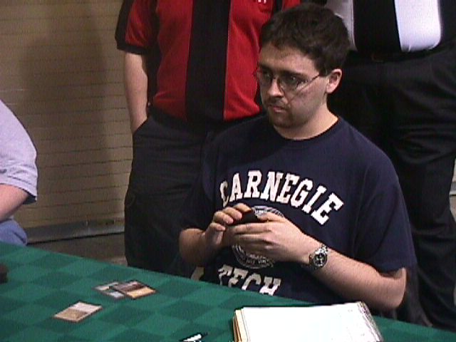
8) Andrew Johnson, 22 points. Member of the new CMU, he too enjoyed a solid PT-NY finish and then a number of good Grand Prix results culminating in 2nd place at GP-Atlanta to get here. Johnson has been working harder than almost anyone has on preparing for Pro Tour: San Diego. If his preparation pays off, he could make a major bid at the top North American player in the standings.
9) Brian Hegstad, 21 points. ABU has not been doing quite as well this season as it did over the course of the last one, but Hegstad is keeping their name in the spotlight. One of the major young talents to emerge on the Pro Tour scene last year, Hegstad is still learning from his teammates and opponents, and keeps getting better and better. He too has the right stuff to stay at the top.
10) Jelger Wiegersma, 21 points. Netherlands is currently rivaling Germany as the strongest Magic player base in Europe. The readers may not know Wiegersma as well as some other top pros, but he has been a successful Pro player for several years. His PT-NO finish propels him toward the top spot, but he will have to fight hard with a slew of good players at 15+ points to remain near the top.
Rookie of the Year top 5 standings:
Amiel Tenenbaum France 20
David Kuykendall United States 12
Takayuki Nagaoka Japan 8
Josh Ravitz United States 8
Bryan Lyons United States 8
Member of Les Plus Class, Amiel Tenenbaum is in a solid lead in the Rookie of the Year race. His most important advantage is having reached the magic number of 20 Pro points - which means he is on the gravy train and will get invites to upcoming Pro Tours. Few of the other players near the top share the same advantage. The key question in this race will be whether Tenenbaum can pick up more than two points per PT to maintain his momentum, and whether any other rookie might finish in the Top 4 of one of the upcoming individual Pro Tours. That would propel them into the point where they can compete with Tenenbaum for the title.

Coming Up: GP-Las Vegas, GP-Curitiba
The Extended qualifier season is just beginning, and the weekend of two Grand Prix will herald it in for the pros. Pro Tour-New Orleans dictates the metagame, with Trix, Turbo-Call and Junk being the three most popular decks. Other decks that finished in the Top 8 are also widely played, as well as the number of other archetypes. Historically, the first several Grand Prix of the season are able to alter the metagame almost as much as the Pro Tour was able to change it from what we saw at Worlds. Will this time be any different?
Las Vegas, with its cheap hotels, cheap food, and exciting attractions, has been a dream of many a pro player when it comes to a location for a tournament. Wizards of the Coast has hesitated for a while, as they do not want Magic associated with gambling - but finally Grand Prix- Las Vegas is going to happen, and most North American pros are going to be there. Organized by the amazing Ray Powers and head judged by Mike Donais, the event is sure to be well run.
Meanwhile, another Grand Prix will be taking place in the sunny Brazil. Justin Polin and I will be attending, and I heard that Ryan Fuller will be going there as well, though this is unconfirmed. Also, several Dutch players are likely to show up. Kai Budde considered going, but the airfare from Germany is high and the trip is long, so he won't be attending.

50th Anniversary
This is the fiftieth week of Week in Review. I would like to thank everyone who has made this column possible (especially Jeff Donais and Omeed Dariani), as well as everyone who has emailed me to contribute to Magic Trivia, Play of the Week and other aspects of the column. If you have any suggestions on further improving Week in Review, drop me a note. My email address is at the bottom of the article.

Magic Trivia
Last week's question:
What is the most expensive 1/1 creature ever printed, in terms of casting cost?
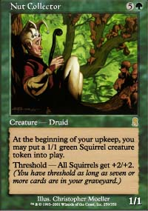
The answer I had in mind was Nut Collector. However, there are several creatures in older sets that are also 1/1 for 6 mana. Among them are Triskelion and Phyrexian Devourer. Nut Collector is, I believe, the only six casting cost 1/1 critter that can't change its power/toughness with an internal ability.
New question:
Courtesy of Greg Buccini:
What Magic card has appeared in most card sets?
Please do not email answers to me. The correct answer will be posted in the next column.

Quote of the Week
"He does not have a Social Security number yet, but he has a DCI number" - Tony Pagliocco, talking about his newborn son.

Play of the Week
Submitted by Tim "Iakae" Sprague
"I was playtesting an Oath variant that I was considering for the upcoming PTQ season. My opponent, Dan, was playing a Sligh deck metagamed for a heavy discard environment. Nothing that he was thinking of playing in an actual tournament, but we were covering all the bases.
I had just Oathed out Crater Hellion, dealing eighteen damage to Dan due to the three Jackal Pups he had been attacking with. I had managed an Ivory Mask, but I knew from an early Duress that he had Anarchy in his hand and was waiting on one last land to cast it. With nothing in play to activate my Oath, having Force of Will as the only counter in my hand with no blue card to pitch to it, and being at the unstable life total of three, I drew my card for the turn. It was Duress, and I tapped an Underground Sea to cast it, fully intending to take the Anarchy.
When he revealed his hand, it contained not one, but two copies of Anarchy, and a Guerrilla Tactics. I sighed with relief and chose the Tactics, which he was unable to cast with his one untapped Wasteland. The Tactics hit the graveyard, activating the 4 damage discard effect, and with no creatures in play and the Ivory Mask protecting me, Dan was forced to deal lethal damage to himself."

Bad Play of the Week
Submitted by Jim Mason:
"I was playing in small Type 1 tournament. Here is the entire game:
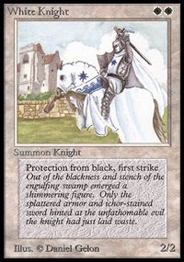
My first turn: lay plains, play Mother of Runes
His first turn: lay swamp, play Dark Ritual, Phyrexian Negator
My Second turn: lay plains, play White Knight
His Second turn: attack with Negator, double Dark Ritual, Hatred for 18.
Me: block with White Knight. First Strike damage on the stack?
Him: Concede.
He accounted for the fact that he would trample over the pro black, but not for first strike. It was fortunate for me that he did not draw a second swamp."
Got an interesting news story, comment, quote, play of the week, or Magic trivia to report? Please e-mail me at ashv80@hotmail.com.

